Slowing down Speed and Adding Duration time
This is very easy to do in the Edit Panel, Just put your clip on the timeline. Right click and select, either change speed or duration
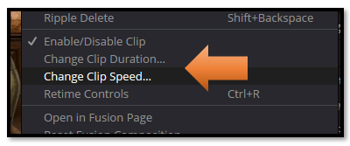
Adding Duration time, can also be done by just stretching out the clip on the timeline and this will also slow down the speed of a clip
